**Impact Evaluation Final**

*The Affordable Care Act’s Impact on Out-of-Pocket expenditures*

Alexander Bactat (2023)

**Motivation**

The original motivation behind this paper was to assess the effect that increased coverage under health insurance would have on income inequality. Due to data limitations and proxy data availability, the motivation pivoted to analyze the impact the Affordable Care Act (ACA) had on one of its intended outcomes: Out-of-Pocket expenses. The original intent of the ACA was to increase the number of Americans who were covered under health insurance—primarily through employment. This increased coverage would result in Americans having greater coverage for medical expenses, which would be reflected in the amount of Out-of-Pocket expenses per capita.

If the ACA was unsuccessful, the resulting treatment effect estimates should be positive, reflecting higher Out-of-Pocket expenses following the introduction of the policy. Further, because of the significantly higher cost of Out-of-Pocket expenses, those for whom the difference in price makes up a significant portion of their net yearly income will suffer disproportionately more, should Out-of-Pocket expenses increase. Increased medical costs could result in individuals delaying certain medical procedures due to affordability, implying the potential for worsening health outcomes among socioeconomically disadvantaged populations.

As such, effect of the ACA on Out-of-Pocket expenses has huge economic implications. These outcomes are of even further interest when exploring the potential implementation of Universal Healthcare in the US.

**Literature Review**

Liu et al. (2020) published a study attempting to identify the association between the US Affordable Care Act and Out-of-Pocket, as well as catastrophic health expenditure1. Controlling for demographic characteristics, they found no significant association between the implementation of the ACA and changes in Out-of-Pocket expenditure. It did, however, find that the implementation was correlated with a 30.4% decrease in Out-of-Pocket expenditure among lowest-income patients. That said, this study was limited to patients with traumatic injury over an 8-year span, starting from 2010, and further limited by the response rate of interviewees to the Medical Expenditure Panel Survey, which may present some selection bias. It also only selected ages 19 to 64 years. While this may be suitable for their analysis, it does present some external validity issues for this paper. That said, the finding that there was significant decrease in the uninsured rate does shed some light on this paper, as a policy implementation that has no effect on the population will likely also not see any downstream effects.

Blavin et al. (2017)2utilized a difference-in-difference model to analyze the effect of Medicaid versus Marketplace coverage for near-poor adults on Out-of-Pocket expenditure and coverage. Their study focused on a state-by-state level of expenditure for incomes at 100%-138% of poverty in Medicaid-expansion states against those in non-expansion states. Their findings find a statistically significantly lower uninsured rate among expansion states and statistically significant decreases in average Out-of-Pocket spending (it is unclear whether this is a per capita estimate, or if this is clustered by state population). While their sample population is different from the scope of this paper, it does point to a more specific outcome of the policy implementation. That said, it does not provide an event study model, which would show if this effect was immediate, sustained, or even lagged. The results are promising, though, from an analysis standpoint.

**Data Description**

The data for this analysis came from the World Bank Data World Development Indicator database, which has longitudinal data many countries at various levels. For this paper, a broad list of fixed effect indicators were used to factor for exogenous trend in Out-of-Pocket expenditure. These includes such factors as GDP, domestic government health expenditure per capita, and current health expenditure per capita covering macroeconomic outcomes, and adolescent fertility rate, immunization against measles, and life expectancy at birth controlling for health outcomes. The goal was to best-capture trend in health expenditure across as many similar countries to the US to capture the proper control population.

The imported data was then pre-processed for analysis. Namely, it required formatting into a panel setting. Given data availability constraints, the timeframe of 2000-2019 was chosen. These years constitute a “Year” column in the dataset, which provided helpful year-effects in the event study model. Another column constituting a dummy variable for the post-treatment period was created, as well as one that flagged the US as the treatment group. Finally, 6 more dummy variables were created to represent the other 6 control countries.

The key outcome variable was listed as “Out-of-Pocket expenditure per capita (Current US$)”. As mentioned, the original variable of interest was closer in topic to income inequality: Gini Index. This is a standardized metric of the degree of income inequality represented in graph form. There were some complications to this variable, though, as macroeconomic changes to income inequality would likely take some years and maybe even a generation to present themselves. This would be far outside the scope of an immediate Difference-in-Difference model, as spurious variables may well present themselves during that horizon. Further, wealth, rather than income, would be the key metric immediately affected by increased health expenditures, as people generally dip into savings to pay for exigent fees rather than take pay cuts.

**Empirical Strategy**

The main method used in this paper is the Difference-in-Difference approach, which attempts to leverage a specific treatment implementation to estimate the average treatment effect between a treatment and control group. In this case, the treatment group will be the US, which enacted a healthcare policy to expand the eligibility of health insurance and pre-existing conditions. The control groups represent similar (and data-available) countries: Australia, Canada, France, Germany, Japan, and the United Kingdom.

After data augmentation procedures, a crude plot of the outcome variable was generated to test the parallel trend assumption. This is a key identification issue for Difference-in-Difference models. If the pre-treatment control trend is radically different from the pre-treatment treatment trend, then conclusions may be hard to reach, as the counterfactual treatment trend may be difficult to estimate. The plot is presented as follows:

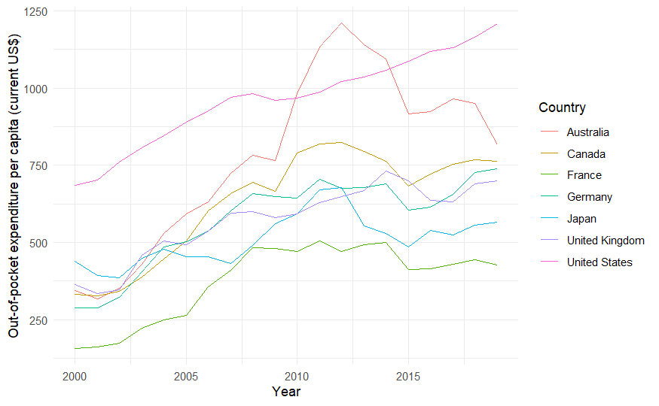

It shows a generally parallel trend among the output variable all of the countries up to the year 2010, where the European countries and Japan seem to plateau while America seems to continue upwards. Australia, on the other hand, begins to outpace the trends of all 6 other countries with an equally precipitous drop in trend following the year 2012. While this may exclude it from the control group, there are also ways to get past the parallel trend assumption, discussed later. Looking at the trend estimates in the pre-treatment period (2000-2010), we get a better look at the respective trends in the control and treatment countries.

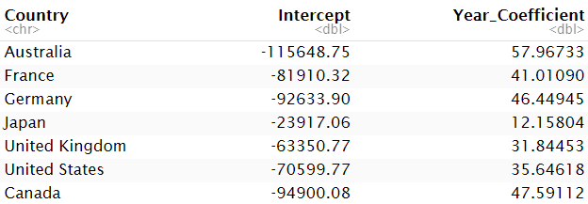

These trend coefficients point to the United Kingdom as the best control group, as it is best in upholding the parallel trend assumption. That said, this paper also factors for country-year effects later.

Moving to analysis, a few iterations of the DiD model were implemented. The simple DiD matrix calculation gives us rough estimates for the treatment effect, as dictated by the basic form:

. This calculation represents the difference between the post- and pre-treatment periods and the difference between the USA and non-USA Countries—hence the term “Difference-in-Difference”. β1 represents the difference in the pre- and post-treatment periods, β2 represents the difference in the treatment and control groups, and β3 represents the DiD treatment effect on the output variable. Running this equation in a lm() model should return the same coefficient estimate.

While this model is beneficial as a starting point, it requires further analysis. Firstly, a time trend analysis of the form



will control for the pre-existing trend. The Yeart coefficient represents the outcome changes each year, controlling for trends. Then, when all else equals zero, the interaction effect β represents the treatment effect.

If the parallel trend assumption is not measured, then there are a few options for controlling for certain endogenous variables. For example, we can also control for country-year effects, not assuming that the trend is the same for all countries across the timespan. This requires the aforementioned country dummy variable as well as the year dummy variable. Taking the form



lets the time trend vary across countries. This helps more accurately predict the DiD treatment effect.

Given that the World Development Indicator database has such a swathe of data across countries, adding fixed effects as well as time-fixed effects would greatly increase the accuracy of the estimated treatment effect. Further, clustering standard errors by country will help us identify trends within countries. The benefit of an event study of the form

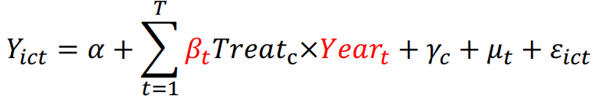

allows for analysis of the DiD estimate in each year relative to the comparison year. For this analysis, it would be the year before the policy implementation, 2009.

**Empirical Results**

The simple DiD matrix gives a crude estimate of the treatment effect.

|  |  |  |  |
| --- | --- | --- | --- |
|  | USA | Non-USA | Difference |
| Post | 1077.35 | 626.186 | 451.168 |
| Pre | 852.991 | 440.337 | 412.653 |
| Difference | 224.363 | 185.849 | 38.5144 |

The difference between these two differences gives us the Difference in Difference estimate treatment effect of $38.51 per capita. The same estimate is found when running a DiD OLS model. Running this model as an OLS estimate, we indeed get an estimate of $38.51 per capita, but find that it is not statistically significant.

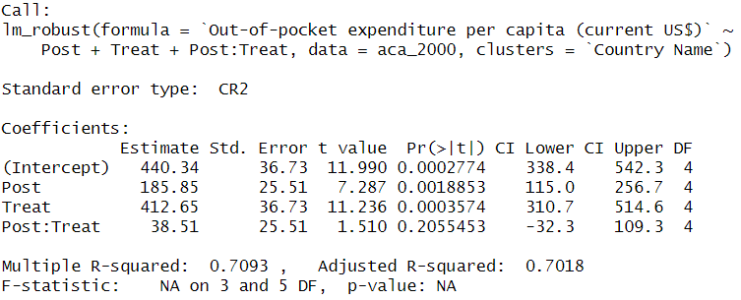

It is important to note that a lack of statistical significance does not necessarily imply that there is no effect, but that other factors could also play a role in the estimate.

Moving to time-trend effects, running the model in code gives the following output: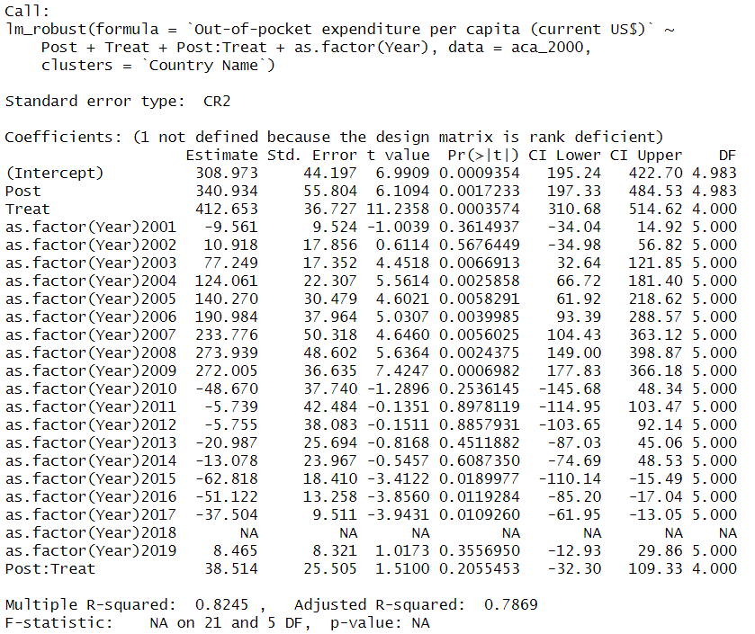

Doing so does not change the estimate of $38.51, and also does not change the statistical significance.

Running the country-year model, we get the following output:

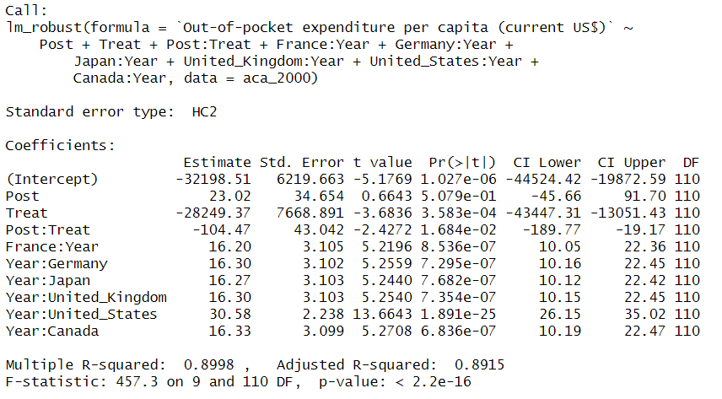

This actually shows a negative DiD treatment effect, which is in stark contrast to the previous estimate. This could be because factoring out the previous trend in the US and taking the others into account, the difference in the post-treatment trend and counterfactual trend in the US is actually negative.

Finally, running the event study model with fixed- and year-fixed effects returns these estimates:

Interaction effect estimate std. error

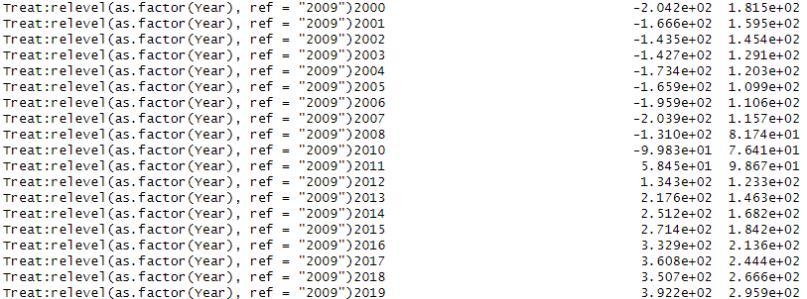

Interaction effect t value Pr(>|t|)

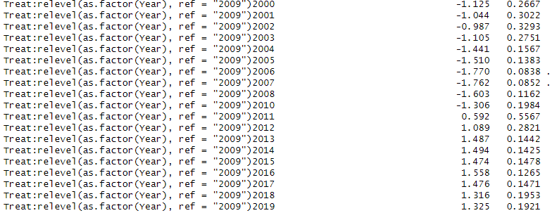

The first thing that can be gleaned from the estimates is that there seems to be a significant increase in the estimate in the treatment effect in 2011, which is exactly the sort of trend we would see if there was a treatment effect in 2010. We can also see that the statistical significance of the coefficients increases drastically post-treatment, though they are still not statistically significant at any level. Again,, this lack of statistical significance does not necessarily imply that the treatment had no effect. To see if there was an effect, it would help to utilize the strength of the event study model, which is that it can show the trend in treatment effects over each year. To put the trends in context, we drop the comparison year of 2009 so that we can truly estimate the effect of the ACA over time.

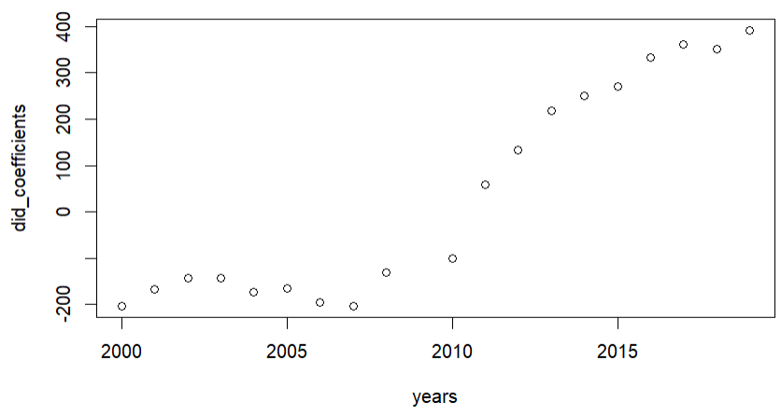

These points represent the DiD treatment effect estimates over time. We see that the estimates are roughly equal pre-treatment. While the parallel trend assumption generally hopes to see these values close to 0, they do happen to be constant, which does satisfy it somewhat. Then, looking at the post-treatment period, we see a consistently increasing treatment effect, suggesting that the ACA had not only a positive effect on Out-of-Pocket expenses per capita, but this effect increased over time.

**Future Work**

More analysis on this phenomenon is definitely required. For example, a robustness check should be used on each model, where a quadratic country-year interaction effect is implemented to make the model more dynamic and robust to non-linear trends. This paper also constitutes a single model and its extensions. It may well be that a regression discontinuity model may be more appropriate, and would better identify the ACA as the cause of the change in Out-of-Pocket expenses. Perhaps instrumental variables are required to reduce some of the noise in the error term and provide more specific causalities. One test that this paper does not run is the placebo test, which attempts to test the parallel trend assumption by applying the DiD analysis to a treatment which should not have any effect. Speaking of the parallel trend assumption, as it requires the control and treatment groups to have roughly parallel trends in the pre-treatment period, there is a question about selection bias. The control group was chosen through bias in terms of culture and macroeconomics, but it may be that another country would act as a better control than the selected countries. Also, after further research, it came to light that the UK enacted the Health and Social Care Act in 2012, which reorganized the structure of the National Health Service in England. While all citizens are covered under the NHS in England, and Out-of-Pocket costs are not a direct motivation behind it, any large healthcare policy that may have knock-off effects on the outcome variable during the post-treatment period in a control group should be disqualifying. This paper is ambitious in that it attempts to analyze country-level fixed effects, and thus does not required a lot of external validity. That said, previous papers that identify the effects of the ACA on specific income groups, specifically low-income groups, may provide different and more specific uses.

**Conclusion**

Running a Difference-in-Difference model with country-level and year-fixed effects shows that the Affordable Care Act had a positive impact on Out-of-Pocket expenses per capita. That is to say, by 2019, Out-of-Pocket expenses per capita per year were increasing in the magnitude of the hundreds. While this may seem a trivial amount of disposable income to some, it very much is not to others. As such, further analyses as to the reasons behind this increase in expense are required to rectify this outcome.

Citation:  
1: Liu C, Tsugawa Y, Weiser TG, Scott JW, Spain DA, Maggard-Gibbons M. Association of the US Affordable Care Act With Out-of-Pocket Spending and Catastrophic Health Expenditures Among Adult Patients With Traumatic Injury. JAMA Netw Open. 2020;3(2):e200157. doi:10.1001/jamanetworkopen.2020.0157

2: Medicaid Versus Marketplace Coverage For Near-Poor Adults: Effects On Out-Of-Pocket Spending And Coverage Fredric Blavin, Michael Karpman, Genevieve M. Kenney, and Benjamin D. Sommers: Health Affairs 2018 37:2, 299-307